|  |  |
| --- | --- |
| **WP 5 (Task 5.1)** | **Guidance** |

**MARBEFES Project**

|  |
| --- |
| **Title: Task 5.1 Guidance for Bow-tie Storyline Creation and Analysis at BBTs**  Delivery date: October 2023 |
| **Project General Coordinator:** Jan Marcin Węsławski  **Project Scientific Manager:** Julie Bremner  **Project Manager:** Joanna Przedrzymirska-Ziółkowska |
| **Task Leader(s)**  Mike Elliott (International Estuarine & Coastal Specialists (IECS) Ltd.) |
| **Author(s)**  Mike Elliott, Katie Smyth, Anita Franco and Roland Cormier (IECS.ltd) |
| **Submission date**  23/10/2023 |

|  |  |  |  |
| --- | --- | --- | --- |
| **Document Version Control** | | | |
| **Version** | **Date** | **Comment** | **Modified by** |
| 1.0 | 12.03.2023 | First draft | M. Elliott  K. Smyth  A. Franco  C. Arvanitidis  D. Burdon  R. Cormier |
| 2.0 | 16.07.2023 | Second draft | M. Elliott |
| 3.0/Final | 23.10.2023 | Final Version | M. Elliott |
|  |  |  |  |

**Title of the document: Task 5.1 Guidance for Bow-tie Storyline Creation and Analysis at BBTs**

# Table of contents

1. Conceptual basis - Introduction to environmental Hazards and Risk

2 Analytical tools available

2.1 Introduction to Bow-tie diagrams

2.2 Examples of Bow-tie use in previous EU projects

2.3 Terminology of management measures – definitions

3 Guide for operationalisation

3.1 Bow-tie diagram creation within MARBEFES

3.2 MARBEFES scenarios/storylines as a basis for the Bow-tie diagrams

3.3 How to form the Bow-tie diagrams

4. References and Further Reading

# MARBEFES WP5 5.1 Scenarios BTs and BBTS

This Guidance Document is created for MARBEFES WP5, T5.1 and aims at defining and operationalizing the concepts of risk and opportunity assessment and management (for example, using the ISO Accredited industry-compliant tool called Bow-tie analysis). It gives the guidance for the Broad Belt Transects (BBTs in WP2) to derive and interrogate the storylines and scenarios.

1 Conceptual basis - Introduction to environmental Hazards and Risk

The coastal and marine environment is subject to many hazards, each with causes and consequences of which marine environmental managers should be aware. In essence, hazards may occur either naturally or by human actions, and they become risks when they adversely affect something valued by humans, such as health, welfare or property (i.e. the objectives of environmental protection as in ISO 31000); consequently, the risk is the probability that a hazard will lead to those adverse consequences on humans and so will include the severity of those consequences In some cases, human responses to one hazard may increase the risks and make the consequences even more severe – for example, removing coastal protection due to mangroves may make the repercussions of cyclones and tsunamis even more severe. Hazard is the cause of an adverse effect compared to risk, which in contrast is the probability of effect (i.e., the likely consequences) potentially leading to more severe consequences to humans. The severity of the risk can be measured by the number of people or the value of the assets likely to be affected. At its most severe, the concept of disaster then represents the interplay between the social and the natural systems.

Responses by society to hazards result from a perception of risk, and the willingness to act depends on the perception and evidence for the consequences, The response in terms of management measures or rather technical measures is to reduce "risk" to a level that is tolerable by society even though perceptions vary individually. For example, the placement of storm surge barriers occurred as a response to the 1953 storm surge in the North Sea and in anticipation of similar events in the future. While Smith and Petley (2009) consider that natural risk can be defined as the damage expected from an actual or hypothetical scenario triggered by phenomena or events following natural events, the previous definitions suggest that that damage should relate to humans to be regarded as risk.

Coastal and marine hazards may be natural or anthropogenic (Table 3) and are divided into those over which individuals or communities have some control, for example, by not inhabiting vulnerable areas, and those where they have no control, for example, tectonic failure or extreme landslip (see Elliott et al., 2014, 2019). Such hazards then require to be tackled using technological, governance and economic approaches, for example, whether we have the capacity in methods, laws and funding to modify and protect coastal landscapes against the influence of hazards or whether we need the capacity to mitigate their effects by financially supporting adaptive measures. A management measure to reduce or nullify that risk could involve merely removing people from the area in which they would be subject to the hazard.

At the same time, coastal management and global agreements must ensure that biodiversity is protected and that management actions implemented at national levels and potentially affecting the natural structure and functioning are sustainable in the long term. Developed countries have the financial and technological means to reduce the vulnerability and thus risk to the effects of change, such as climate change (e.g., Blasiak et al., 2017; Ding et al., 2017), such as building defences, but this is an expensive option. Underlying this is the need and requirement to protect societal benefits such as infrastructure and urban areas, while at the same time protecting the natural system and its delivery of ecosystem services. Hence, while we have the capacity to engineer the coastline to protect it from hazards, this would be at the risk of creating a non-natural system, thus contravening nature conservation agreements and laws. Coastal industries will be similarly faced with such decisions in protecting their assets while at the same time ensuring that their activities do not adversely affect natural systems.

In wider terms, natural phenomena that can create risks can be divided into two main categories depending on the source of the causes: endogenous phenomena and exogenous phenomena in relation to their source, respectively, within or on the Earth’s surface. Endogenous causes, for example, include those which can release huge amounts of energy from seismic or tectonic events, and thus are seen as earthquakes and volcanic eruptions and tsunamis, wrongly termed tidal-waves, which emanate from these. Exogenous phenomena, such as landslides, floods and accelerated erosion (of beaches and riverbeds), are often, but not necessarily always, linked to extreme meteorological events and act on the Earth’s surface, tending to modify the landscape. The nature of the landscape has to be such that it cannot accommodate such forces without resulting modification; for example, flat landscapes will exhibit greater change by flooding than ones with greater elevation. Such phenomena are an expression of the internal and external geophysical dynamics and represent the natural evolutionary processes. However, by interacting with societal components (population, settlements, infrastructure, etc.) they frequently define risk conditions. While natural systems have the capacity to adjust to such natural changes, it is only when the natural and societal aspects interact that we see hazards and risk, both terms being used in relation to human uses of the geographical space.

Floods, landslides, the instability of the coastline, abrupt subsidence and substratum failure are all either the cause or effect of natural events, which are generally grouped as hydrogeological phenomena. All of these are likely to affect coastal industries and populations adversely. These changes result from the interaction between meteorological events and the geological, morphological and hydrological environment, in which humans either play an important role by making the landscape more susceptible to change or are significantly affected (Torresan et al., 2014). Clearly, natural phenomena can cause disasters, but human actions often make them more severe. For example, in assessing the causes and consequences of the Katrina hurricane in August 2005, Austin (2009) showed that the situation was made worse in Southern Louisiana. These included its often-poor human population being less able to withstand the changes, a long history of coastal modification by natural and man-made levees and other modifications through canal construction and the oil exploration and extraction industries. In essence, the loss of coastal wetlands removed a capacity to cope with natural events such as hurricanes, a poor and poorly prepared population was unable to cope with the after-effects, and a large amount of unsuitable city infrastructure then increased the repercussions of the hurricane.

While determining the individual effects of each of these hazards and risks, the major challenge for the environmental and operational managers of coastal activities is determining the effects of several or many hazards acting together. These interactions, termed cumulative impacts or effects assessment, may be synergistic (additive) or antagonistic (cancelling) (see below).

Table 3. Typology of Hazards in Coastal and Coastal Wetland Area. Adapted and expanded from Elliott et al. (2014), in Elliott et al. (2019).

|  |  |  |
| --- | --- | --- |
| **Hazard** | **Natural or Anthropogenic?** | **Examples** |
| A) Surface hydrological hazards | Natural but exacerbated by human activities | High tide flooding, spring tide and equinoctial flooding; flash flooding, El Niño Southern Oscillation/North Atlantic Oscillation patterns; flow delivery repercussions of catchment modifications (land use increasing sediment loading, dams decreasing peak flows and sediment loadings, etc.) |
| B) Surface physiographic removal by natural processes - chronic/long-term | Natural but exacerbated by human activities | Gradual erosion of soft cliffs by slumping, estuary bank erosion by prevailing currents |
| C) Surface physiographic removal by human actions - chronic/long-term | Anthropogenic | Land claim, removal of wetlands for urban and agricultural area |
| D) Surface physiographic removal - acute/short-term | Natural | Cliff failure, undercutting of hard cliffs and intermittent erosion |
| E) Climatological hazards - acute/short-term | Natural but exacerbated by human activities | Storm surges, cyclones, tropical storms, hurricanes, offshore surges, fluvial and pluvial flooding |
| F) Climatological hazards - chronic/long-term | Natural but exacerbated by human activities or anthropogenic | Ocean acidification, sea level rise, storminess, ingress of seawater/saline intrusion |
| G) Tectonic hazards - acute/short-term | Natural | Tsunamis, seismic slippages, earthquakes |
| H) Tectonic hazards - chronic/ long-term | Natural | Isostatic rebound, subsidence |
| I) Anthropogenic microbial biohazards | Anthropogenic | Sewage pathogens |
| J) Anthropogenic macrobial biohazards | Anthropogenic | Alien, introduced and invasive species, Genetically Modified Organisms, bloom-forming species |
| K) Anthropogenic introduced technological hazards | Anthropogenic | Failures or mismanagement of infrastructure, coastal defences, catchment impedance structures (dams, weirs) |
| L) Anthropogenic extractive technological hazards | Anthropogenic | Removal of space, removal of biological populations (fish, shellfish, etc.); seabed extraction and oil/gas/coal extraction leading to subsidence |
| M) Anthropogenic acute chemical hazards | Anthropogenic | Pollution from one-off spillages, oil spills |
| N) Anthropogenic chronic chemical hazards | Anthropogenic | Diffuse pollution, ocean acidification, litter/garbage, nutrients from land run-off, constant land-based discharges, aerial inputs |
| O) Anthropogenic acute geopolitical hazards | Anthropogenic | Terrorism attacks leading to damage to infrastructure |
| P) Anthropogenic chronic geopolitical hazards | Anthropogenic | Wars created by shortage of resources (e.g., land, water, minerals) |

The environmental manager/marine user will be concerned with each and every effect of their activities from inception through construction and operation to decommissioning. The activities will each have a footprint (i.e., where and when the activities take place and where they are licenced), which then gives rise to perhaps larger pressures-footprints, as the mechanisms of effects, and then to perhaps even larger effects-footprints in space and time of both the natural and societal systems (Elliott et al., 2020c). However, the manager will also have to be concerned with the effects of other activities inside the management area (causing endogenic pressures) and those changes inside an area due to factors outside the immediate management area (exogenic pressures). In essence, an environmental regulator will be able to sanction activities occurring within in an area through permits, consents, licences or authorisations, whereas the exogenic pressures require initiatives outside the management area, such globally controlled carbon emission regulations.

The essence of management for an industry or individuals, whether environmental or operational, is undertaking risk assessment and management and, where possible, opportunity assessment and opportunity management.

Risk assessment includes knowing:

* What and where are the causes of the problems, and what changes do they cause;
* what is their impact on ecosystem structure and functioning, including both the natural and human domains of the ecosystem;
* what are the repercussions for ecosystem valuation based on economy-ecology interactions, and
* what are the future environmental changes and economic futures for the industry.

Consequently, risk management includes knowing:

* what governance framework is there;
* what do stakeholders need, i.e., what are the priorities and concerns of other stakeholders;
* what are successes and failures;
* what can the industry, regulators or society do about the problems, hazards and risks, and how can they address them now and in the future, and
* how robust is the decision-making.

This requires knowing and using the above (Table 3) hazard and risk typology, showing what risks and hazards are created by activities, the responses of the receiving environment and the natural and societal receptors to the activities/pressures/effects, and the controls (Programmes of Measures) that are imposed on those activities by the regulators. Again, by definition, a hazard can occur in the environment, whether naturally or by human actions, and then it becomes a risk if it affects something we value. Those risks can be exacerbated by human actions, for example, by removing natural coastal defences, thereby leading to greater coastal erosion. This complexity of many activities, pressures and effects all operating in an area requires the need to consider Cumulative Impacts Assessment (CIA)/Cumulative Effects Assessment (CEA) (NB, both terms have been used interchangeably in the literature thus the choice appears to merely be semantics and the preferences of an author (Blakley and Franks 2021)).

It is considered here that CEA/CIA has many challenges with the need to determine:

* ways of increasing our limited ability to measure the spatial and temporal effects-footprints of pressures from named activities;
* the extent, duration and frequency of the pressures from an activity, not just the activity itself in a given place at a given time (note that the term activity is not equivalent to the term pressure);
* the relative effects of pressures from outside an area overlaying those caused by the industry itself;
* the weighting given to the different effects-footprints in space and time, not just assuming they are added (synergistic) linearly and arithmetically (they could be antagonistic (cancelling) or even linked exponentially);
* knowing what is in an area, what activities are present, what receptors there are, and what is their relevance;
* tackling the effects-footprints on the mobile receptors (mostly species, such as birds, fish and marine mammals passing through an area), not just the sedentary receptors (habitats and benthic species);
* accepting the assumption that CIA relates to ‘all impacts of all activities’, not just ‘all impacts of one activity/sector’ (the latter is just an Environmental Impact Assessment (EIA) carried out properly);
* whether there is a tipping point or threshold to an undesirable state when all impacts are taken together, and the effects-footprints overlap;
* the process of the effect of the activity of an industry and its pressures increasing the chances of moving from an impact on the natural receptors to those on the human receptors, thus moving along the continuum from ecosystem structure and functioning of ecosystem services to societal goods and benefits;
* for larger water bodies, playing a role in tackling the conceptual difficulties in the continuum from an EIA to CIA to Strategic Environmental Assessment, Maritime Spatial Planning and Integrated Coastal Zone Management.
* ensuring that programmes of measures are sufficient to control the sums of the activities, their pressures and effects on the natural and social systems both within and between nationally-defined management areas;
* finally, and perhaps the largest challenge, that the current system of managing activities (and their pressures and effects) are within national boundaries according to those nation-state administrative bodies and so managing transboundary areas and water bodies requires coherence and equivalence across boundaries (Cormier et al 2022; Elliott et al., 2023). .

2 Analytical tools available

2.1 Introduction to Bow-tie diagrams

Marine management fits within an overall DAPSI(W)R(M) (pronounced dap-see-worm) framework, the cause-consequence framework that links Drivers, Activities, Pressures, State change, Impacts on human Welfare and Responses as management Measures. This is required to determine the risks and hazards to the marine system from natural and human causes and how those risks and hazards can be overcome using a programme of management measures (Elliott et al., 2017). In turn, such an approach can also be used to determine the opportunities in the marine system, which can be affected using a holistic management system (e.g., as carried out using a stakeholder-led approach in the EU FP7 Project CERES, Elliott et al., 2020b). This, in turn, is embedded in a systems analysis approach for integrated marine management (Elliott et al., 2020a), as indicated by Figure 1 (from Elliott, 2023).

Bow-tie analysis is an industry-propagated analytical approach for risk assessment and management, which can be easily adapted for opportunity assessment and management – essentially a cause-consequence-response approach (IEC/ISO, 2009). It is an ISO-31000 compliant method for producing conceptual models (Cormier et al., 2013, 2018, 2019). It addresses a risk or problem and indicates the causes of that problem, ways to prevent those causes and mitigate the resulting consequences that occur because of the problem.

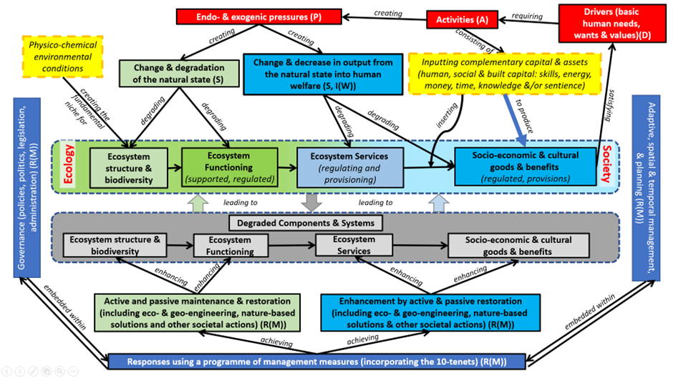

Figure 1. The socio-ecological system aiming to unify the DAPSI(W)R(M) framework, the means of degrading the natural system and recovery management measures, and the ecological structure and functioning to ecosystem services and societal goods and benefits continuum. From: Elliott (2023).

As the proposed structure for the Bow-tie diagram analysis in this project, the central knot of the Bow-tie diagram represents a particular risk (e.g., loss of profits for a specific fishery due to climate change, or risk of not meeting biodiversity targets). The left side lists pathways of potential causes (Figure 2 – generic model), whereas the right-side lists consequences resulting from the event. Controls to reduce or prevent the consequences are positioned along the pathways of risks on the left (solutions to prevent the central event) and on the right (mitigation/compensation and recovery from the central event). The prevention measures are aimed at stopping the hazard, stopping the hazard becoming a risk or reducing the likelihood that the hazard will occur or create consequent risks. Escalation factors, which undermine the effectiveness of a given control, can also be added with additional barriers. Hence, the scheme can accommodate uncertainty in risk management. The performance of management control in managing or reducing these uncertainties relies on a suite of barriers that eliminate, avoid or control the likelihood of a given risk to occur or to mitigate or recover from the consequences of a given risk. Barriers implemented closest to the sources of the risk (e.g., at the site of an activity) provide the greatest assurance in reducing uncertainty in achieving environmental management objectives. At the same time, determining the prevention or response to risk allows the opportunities to be defined for the sector in question to accommodate impacts and enhance growth successfully.

Figure 2. A simplified generic Bow-tie structure overlain by the DAPSI(W)R(M) framework (see text).

A key advantage of this method is that the Bow-tie concept visualises the risks being considered in one clear and easy-to-read picture (Figure 2) or the Figures 3 and 4 as created by the proprietary software (Bow-Tie XP – see https://www.wolterskluwer.com/en-gb/solutions/enablon/bowtie/bowtiexp). Shaped like a bow-tie, the diagram creates a clear differentiation between preventative and mitigation/compensation/adaptation measures – effective ways to prevent an event from happening, and if it does, ways to mitigate any effects; the latter step will also include any compensation, adaptation and control measures. The power of a Bow-tie analysis is that it shows a summary of numerous risk scenarios in a single, easy-to-follow picture that can be understood by all levels of an organisation, as well as the general public. In short, it provides a simple, visual explanation of a risk that would be much more difficult to explain otherwise.

Originally designed for use within sectors such as the aviation industry and health and safety practices, the Bow-tie concept is a risk management tool supplementing cause-and-effect and impact assessments to manage the risks of potentially catastrophic events in a broad range of industry sectors. It provides a systematic approach to assuring control over environmental, health and safety hazards. It is increasingly used for the ecosystem approach and mapping environmental and ecological risks and their management (e.g., Burdon et al., 2018; Elliott et al., 2020b). This approach has been recommended by ICES and the Department for Fisheries & Oceans Canada as their preferred risk assessment and management methodology (Cormier et al., 2013).

The DAPSI(W)R(M) framework is easily overlain onto the Bow-tie analysis, making it ideal for ecological risk assessment and management (Figures 1-4). This encompasses Drivers, Activities, Pressures (as mechanisms of change), State change (on the natural system), Impact (on human Welfare), and Responses (using management Measures), which are based on the 10-tenets for successful and sustainable marine management (Elliott, 2013; Barnard and Elliott, 2015) (Table 4). In essence, the D, A and P are the left-hand side causes of both the central problem and the consequences (both the central knot and the right-hand side consequences reflect the S (on the natural system) and the I(W) on the human system. The R(W) management initiatives are then reflected by the prevention and mitigation/compensation controls acting on the causes.

Figure 3. Simplified Bow-tie with DAPSI(W)R(M) overlain – to determine causes and consequences and to agree on the responses throughout the sequence, as created by proprietary software (Cormier et al., 2019).

Within recent ecological applications of this process (Elliott et al., 2020b), potential opportunities arising from the problem/central event have also been explored. These can be represented on the Bow-tie diagram on the right-hand side together with the consequences.

Figure 4. Bow-tie Analysis as a Problem-Structuring Method with the DAPSI(W)R(M) framework embedded (First used in the EU CERES project as a novel attempt to use BT analysis for climate change repercussions for fisheries and aquaculture) (Cormier et al., 2013, 2018, 2019).

Table 4. The 10-tenets for successful and sustainable marine management – used to create the responses using management measures.

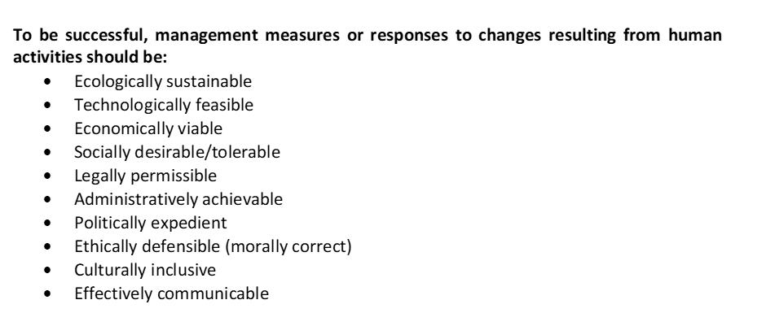

In summary (see Figure 5), a Bow-tie depicts: what is the problem of concern, what are the causes, what are the prevention mechanisms, what are the mitigation/compensation measures, and the consequences (and if there are any opportunities).

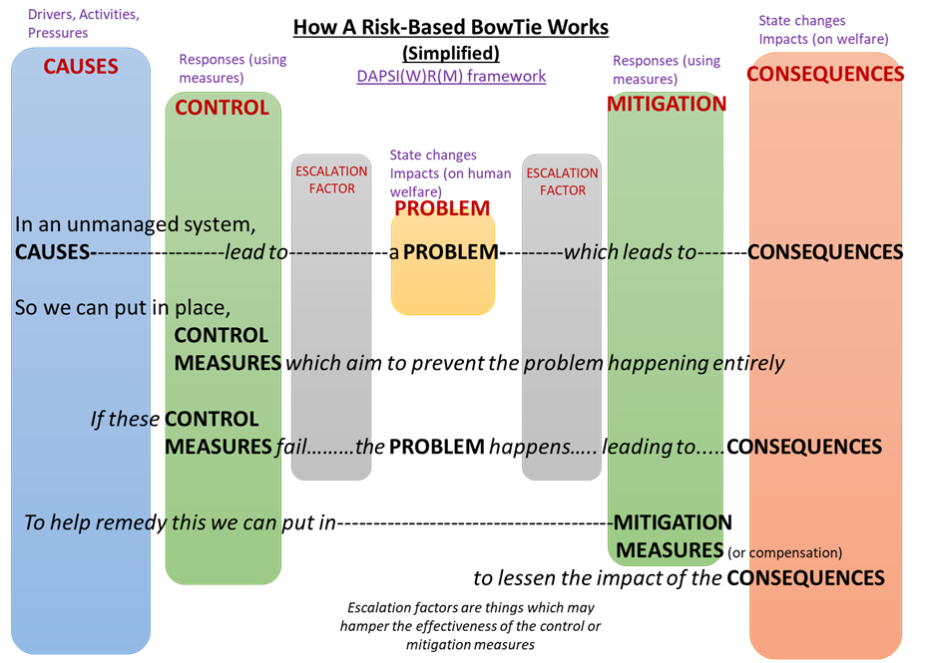

Figure 5. The explained background to elements of the Bow-tie method – the ‘escalation factors’ may enhance or hinder the action of the prevention, mitigation, compensation, adaptation and control measures (see Cormier et al., 2019).

2.2 Examples of Bow-tie use in previous EU projects

Figures 6 and 7 are examples of Bow-tie diagrams used in two recent EU projects, VECTORS and CERES, showing how the Bow-ties can be adapted for each unique situation either through the use of specialist structured software (Figure 6, VECTORS) or via the use of conceptual diagrams (Figure 7, CERES). The examples given were created by stakeholder-led panels.

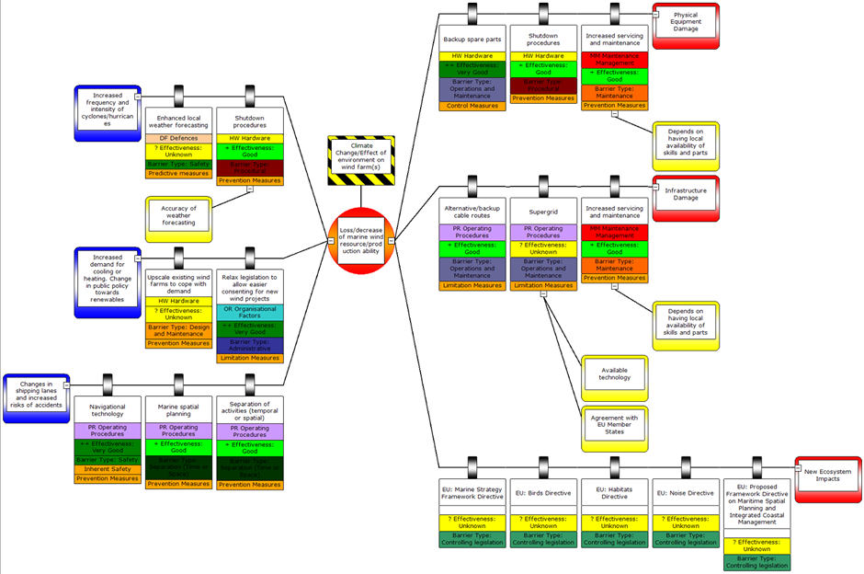

Figure 6. Bow-tie for climate change effects on OWF EU VECTORS Project (See also Burdon et al., 2018).

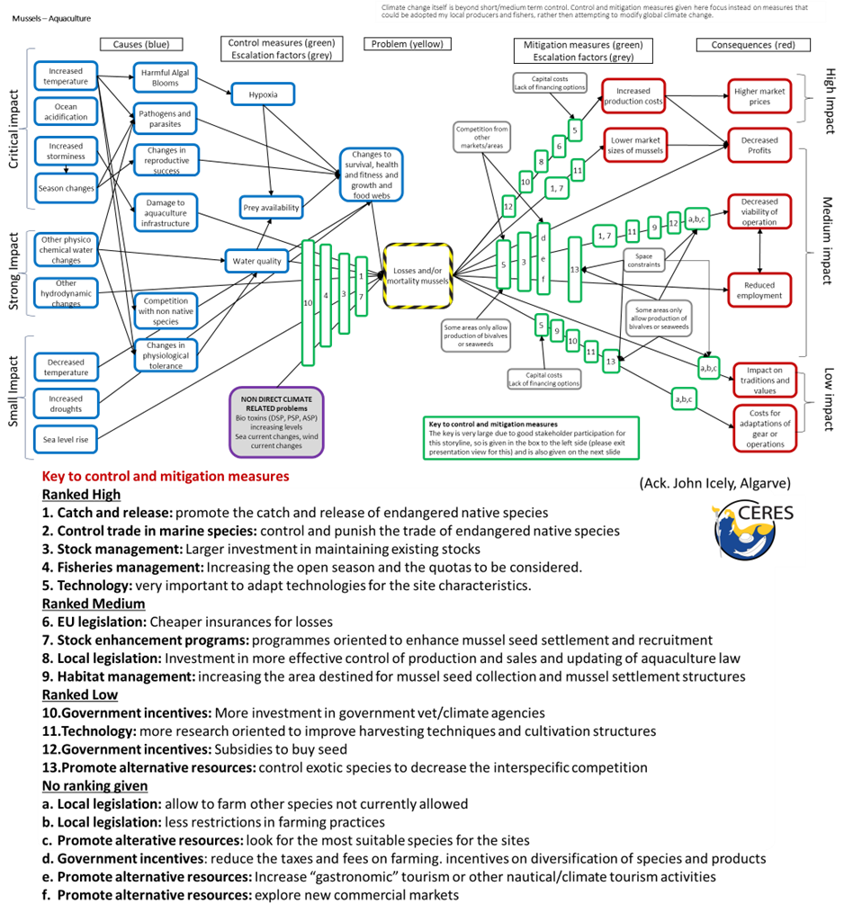

Figure 7. A complex example Bow-tie from the EU H2020 CERES project [includes a key to the mitigation and control measures] (Elliott et al., 2020b).

2.3 Terminology of management measures – definitions

Once the causes and consequences of changes to the biodiversity within BBTs have been determined, the more important part of this sequence is determining management measures to prevent or accommodate the consequences. The management measures adopted in risk assessment and risk management terminology rely on prevention, mitigation, adaptation, compensation and control. In general, mitigation is used to reduce the adverse effects, adaptation is a means of coping with those effects, and compensation is a means of accommodating those effects.

In general, the term mitigation can be used for almost all management measures and in the Bow-tie analysis here, the type of mitigation measures depends on the central event. In terms of the Bow-tie, it is usual to attempt to prevent the central event from occurring. A Bow-tie diagram and the ISO standards aim to structure the management risk along proactive (prevention) and reactive (mitigation and recovery) management strategies, where proactive strategies provide the least uncertainty of achieving policy objectives while reactive strategies have the most uncertainty of achieving objectives.

In contrast, when adaptation is used, as in the case of the Intergovernmental Panel on Climate Change (IPCC), it does not classify the risks in terms of management strategies because it focuses on the consequences of climate events (heat, storms, etc) and the effects of climate change on the environment and people. The IPCC uses a risk assessment approach based on likelihood and consequences (impacts) (e.g., Hidalgo et al., 2022), while the Bow-tie is a risk management approach aimed at reducing the effects of uncertainty in achieving objectives by implementing (i) proactive management strategies to prevent the problems that could undermine the objectives, and (ii) reactive management strategies to reduce the consequences when the proactive management strategies fail. It is emphasised that management may merely mean removing the pressures and allowing the system to recover.

The definitions above have led to the development of the generic Bow-tie (Figure 8), which is based on three standards: the IEC/ISO (2009) definitions and their concepts, the application in environmental management in the Australian standards HB 203: 2012, and the most recent version of IEC/ISO 31010:2019 which generalised the measures as preventative and reactive management measures (Cormier et al., 2019). These show that prevention controls the cause to reduce the likelihood of an event, mitigation reduces the magnitude of the consequences of an event, and recovery controls recover from the consequences of an event that could not be mitigated. IEC/ISO 31010: 2019 introduced the concept of cascading events, where a consequence of an event becomes the cause of a subsequent event. This version also includes management activities to support the implementation of a control in addition to escalation factors and controls.

The further management measure, compensation, is used to allow both the ecological system and the uses to accommodate adverse changes even if the changes are not prevented. There are three types of compensation (Elliott et al., 2016) – (i) to financially compensate the users, such as fishers, for the loss of income, (ii) to compensate the resource, such as by restocking or replanting, and (iii) to compensate the environment by re-creating or creating new habitat to allow for the loss in-situ or elsewhere.

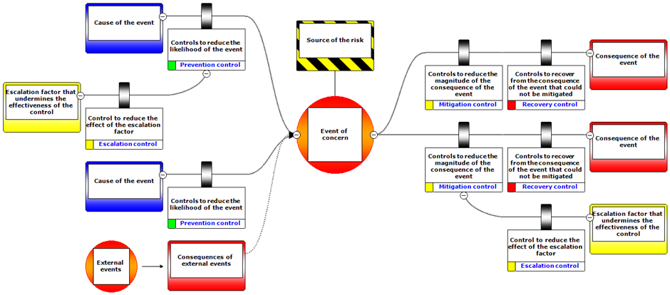

Figure 8. Generic Bow-tie (created using BowTieXP).

3 Guide for operationalisation

3.1 Bow-tie diagram creation within MARBEFES

Within MARBEFES, the approach aims to use case-studies (the relevant storyline(s) for each of the BBTs) to produce Bow-tie conceptual models, which can be formed by asking the following question: “*What are the main issues/concerns in your BBT regarding risks to biodiversity and require management* of *the human activities and their relevant pressures?*”. This important question frames the storyline(s) for each BBT and will form the central knot of the Bow-tie. Once the storyline(s) for each BBT has/have been selected, the main question to interrogate the storyline is: “*In relation to the selected storyline, what are the causes and consequences of risks to biodiversity in your BBT, and how can the causes (human activities) be best managed to reduce the pressures to a level that will allow the appropriate biodiversity to be achieved and maintained?”.* However, this may be regarded as a high-level storyline and a lower-level may be *‘What are the causes and consequences of the loss of habitat xxx?’* or *‘What are the causes and consequences of the increase in non-indigenous species?’.*

The causes relate to the drivers, activities and pressures identified in the BBT, using information from the high-level stakeholders in WP1 in MARBEFES, as well as those acknowledged by the project partners within the BBT (WP2). This should then cover the endogenic causes (those emanating from within the BBT and in which both the causes and consequences can be addressed by management measures inside the BBT) and the exogenic causes (those emanating from outside the BBT and in which the causes are controlled globally but the consequences have to be addressed inside the BBT, for example, climate change). In order to answer this, the questions needed to specify that storyline (i.e., to build the Bow-tie) are:

* What causes this/these issue(s)/concern(s)? What pressures are caused by human activities?
* What are the consequences of the issue(s)/concern(s)? What are the consequences to specific descriptors?
* What opportunities (if any) come from the issue(s)/concern(s)? What are the drivers that are seeking the opportunities?
* What can be done as management measures (i) to prevent the issue(s)/concern(s) from happening, (ii) to adapt, control, mitigate and/or compensate for the consequences if the issue(s)/concern(s) does/do occur? How can these measures reduce the pressures and what mitigation is needed when biodiversity is adversely affected due to non-natural causes?
* What factors can enhance the management measures, and what factors can cause them to fail? What are the escalation factors that contribute to the pressures and undermine biodiversity?

Some semi/quantitative assessment is likely to be needed in the MARBEFES operationalisation of the Bow-ties, and a semi-quantitative assessment could be easily integrated when questioning stakeholders and others (see above, relating to causes, consequences, mitigation/prevention, and opportunities). This could be achieved by asking expert stakeholders to distinguish more/less likely causes, or higher/lower risk of consequences. For example, this approach was used in the CERES project and was done via an online questionnaire sent to stakeholders for each storyline with back-end software that could (semi)quantitatively assess responses and answers via computer to rank outputs of most/least impact.

To allow a fully quantitative assessment, indicators for the different elements of the Bow-tie would need to be identified, for example:

* How do we measure the cause (e.g., pressure)? Do we measure the indicators for the pressures as listed in MSFD 2017/848?
* How do we measure the biodiversity change, etc.? Do we measure the indicators for biodiversity as Descriptor 1 in GES as listed in MSFD 2017/848?

As shown here, it is emphasised that in the context of MARBEFES, and the application to European water bodies, the definitions and approaches given in the Directive, its Annexes and its Guidance documents should be used where possible. The tools/models provided in WP3, WP4 and WP5 in MARBEFES and available to the BBTs could allow us to parametrise/quantify the different cause-effects links within the Bow-tie framework (e.g., how much the provision of a benefit is expected to change (based on its quantitative indicator) as a consequence of a change in the biodiversity component (non-mitigated or mitigated)?).

Different models/tools, including conceptual approaches, may be able to quantify different parts of the Bow-tie, with the Bow-tie providing the framework for linking all these models into assessing the storyline. This would also allow the identification of gaps (general or specific to the BBT) where some links cannot be quantified (e.g., due to a lack of data or models to do so). Alternatively, as performed in CERES, a Bayesian Belief Network (BBN) model could be built using the Bow-tie as the conceptual model to define its structure.

3.2 MARBEFES scenarios/storylines as a basis for the Bow-tie diagrams

The stocktaking of pressures and impacts in WP2 of MARBEFES will allow the BBTs to generate one or more storylines in their case study area to determine and quantify the causes and consequences of change in both the natural and socioeconomic systems. It is important at this early stage to keep the initial generation of the Bow-tie diagrams simple and linked to the MARBEFES project aims. The aim is to create a list of all the possible elements that can go in the Bow-tie, bearing in mind that they may occur along different levels of the chain of cause-consequences that lead to the main problem and that span from it. When defining the Bow-tie for their specific problem of interest, the BBTs can create from these lists whatever is relevant to their case (or add missing elements) and link them as appropriate. It is important to define and be clear about the central problem/aspect and present it in terms easily understood by the stakeholders – hence, the central problem/issue is the main aim of the approach.

Therefore, as with CERES, a single Bow-tie can (and should) include the elements of both the ecological and societal aspects. Table 5 gives examples of the causes and consequences which can be incorporated into a Bow-tie storyline or storylines at the BBTs.

Table 5. Examples of these for MARBEFES – Scenarios/Storylines - Basis for Bow-Tie.

|  |  |  |
| --- | --- | --- |
| **Causes** | **Central ‘knot’ or problem of concern:**  The non-natural change (loss or gain) in marine biodiversity at the BBT area | **Consequences**  **(adverse or opportunities)** |
| Loss of natural connectivity.  Anthropogenic loss of connectivity.  Introduction of anthropogenic structures.  Introduction of contaminants.  Removal/reduction of a commercial species.  Removal/reduction of a non-commercial species.  Removal/reduction of an iconic species.  Reduction/loss of particular/named habitat area.  Reduction of named habitat quality.  Increased exploitation of a biological resource.  Increased exploitation of a physical resource.  Change to water quality.  Change to sediment quality.  Climate change – increased acidification.  Climate change – increased SLR.  Climate change - increased temperature.  Climate change – change to species distribution.  Climate change – physico-chemical water quality changes (other than those specified above).  Climate change – increased storminess.  Climate change – changes in seasonal/temporal patterns of abiotic/biotic processes.  Reduction of primary production – water column.  Reduction of primary production – bed.  Overall reduction in ecosystem service a, b, ….  Changes to the sum of biological traits.  Changes to the habitat mosaic.  Reduction/loss of functionality of an area (and the multiple habitats within) (e.g., as essential fish habitat). | Loss of employment.  Change of the method of exploitation.  Resultant change to health of named species.  Resultant change to a named ecological community.  Change to exploiting other species/new markets.  Loss of societal goods and benefits, of income or cultural benefits.  Loss of physical resources (e.g., space, seabed).  Loss of biological resources (e.g., fisheries).  Reduction of ability to cope with/mitigate for climate change effects" (incl. reduction in carbon storage, lower protection against extreme events, etc.).  Influence on EU Biodiversity Strategy 2030.  Influence on SDG14.  Breach of Marine Strategy Framework Directive.  Breach of Maritime Spatial Planning Directive.  Breach of Bird Directive or of Habitat and Species Directive.  Breach of Regional Seas Conventions demands.  Overall reduction in societal benefits x, y, …..  Reduction of commercial species population(s) leading to a loss of societal goods and benefits.  Activities change or displacement outside the Learning Site area (and related social-economic consequences, e.g. loss of certain types of businesses, impact on local communities).  Loss of local culture, tradition and values.  Increased competition for the (more) limited resources.  Increased prices/costs (incl. Market price of resources, costs for accessing/extracting the resources (goods) or benefits under the changed conditions).  Loss of tourism. |

MARBEFES aims to determine the methods and approaches relating to the assessment of biodiversity (its ecological, socio-ecological and socio-economic assessment and valuations) and, where it is not met, the means of marine management to rectify this. Hence, there is a need to include the cascade from Natural Capital (Habitats and Species), Ecosystem Services (Processes) and Societal Benefits. The first two components are within the 'natural environment' and are reflected in the State change component in DAPSI(W)R(M), whilst the Societal Benefits relate to humans and, therefore, are in the 'societal domain' are reflected in the Impacts (on Welfare) component. Figure 9 identifies the Natural Capital, Ecosystem Services and Societal Benefits within a generic marine system and may be useful for users when considering elements to incorporate into Bow-ties.

Formulating a Bow-tie based on a generic problem may be challenging as the causes and consequences of the central issue/problem can include both natural and anthropogenic factors, which are often interrelated. Hence, a Bow-tie should be designed for a specific problem, for example: a central specific problem regarding a reduction in environmental quality and hence an ability to stop a non-natural change in biodiversity, such as the loss (of area or quality) of biodiversity. It is, therefore, easier to identify the cause(s) and consequence(s) of a focused, specific central problem (both linked to the natural and the anthropogenic aspects) passing through the centre of the Bow-tie. It would be straightforward then to e.g., colour code natural or anthropogenic elements differently for ease of understanding.

As carried out for the CERES project, it may also be appropriate to have one cause leading to another cause and one consequence leading to another consequence, etc. Consequently, that project derived chained BTs. The models created in CERES also colour-coded adverse consequences differently from opportunities. In addition, and as linked to the underlying rationale for the project in MARBEFES, there is the need to keep in mind the environmental quality repercussions to the ecological and socio-economic aspects.

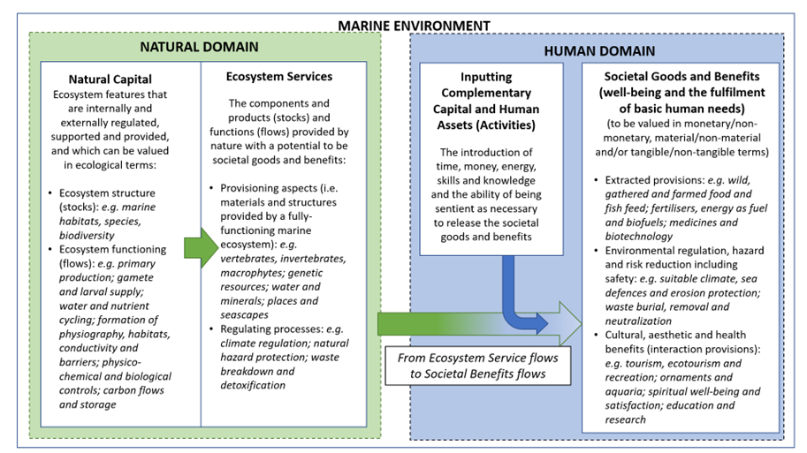

Figure 9. A unified ecosystem services and societal goods and benefits model. From: Elliott (2023).

3.3 How to form the Bow-tie diagrams

Although there is proprietary software for creating Bow-tie diagrams, as used to create several of the above diagrams, it is emphasised that this can be achieved more simply using Power Point (as in the CERES project). As shown in the examples in Elliott et al. (2020b), once several or many Bow-tie diagrams have been created, the common elements and conclusions can be determined.

**Step 1: The central problem.**

Also known as the knot, the event being the problem or the issue, this is key to forming the Bow-tie or what is the problem of concern? Examples of possible central events could be:

* The possibility of any of the hazards and risks identified in Table 3.
* Environmental consequences of construction, operation and/or decommissioning techniques of human activities.
* Economic costs or benefits of different technologies in the activities.
* Environmental consequences of climate change on the habitats, ecosystems or activities.
* Enhanced climate change adaptation and mitigation.
* Influence on other marine uses and users.
* Economic benefits of adaptation techniques.

**Step 2: Causes and their prevention/mitigation/compensation:**

* What are the causes of the central event/problem?
* What mechanisms can prevent these causes from leading to the central event?
* What management measures can be applied to reduce the magnitude or likelihood of the central event happening due to the causes? (e.g., to adapt, control, mitigate or compensate?)
* What factors can enhance the management measures, and what (escalation) factors can cause them to fail?

**Step 3: Consequences and opportunities:**

* What are the consequences (negative) arising from the central event/problem if no actions were to be taken? (e.g., the effects on the ecosystem and its habitats, Ecosystem Services and Societal Goods and Benefits)?
* Are any opportunities (positive consequences) arising from the central event/problem?
* What management measures (based on the 10-tenets) can be applied to reduce the magnitude or likelihood of the consequences (e.g., to adapt, control, mitigate or compensate)?
* What enhancement measures can be applied to reduce or increase the benefits from any opportunities (positive consequences)?
* What factors can enhance the management measures, and what (escalation) factors can cause them to fail?

Hence, the approach can be presented as a framework for tackling the problem and identifying opportunities (Figure 10).

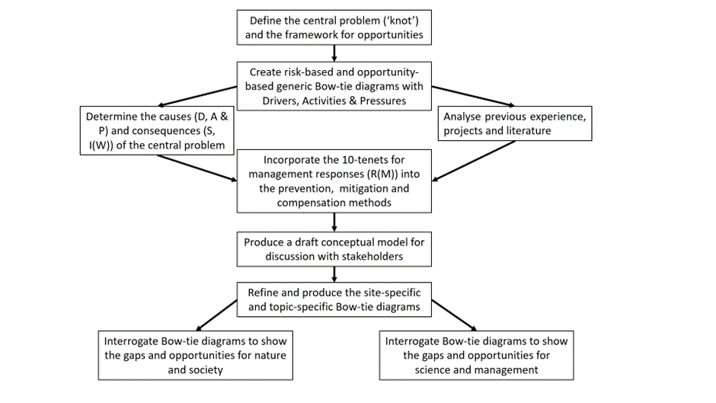

Figure 10. Flowchart for structuring a Bow-tie diagram for risk and opportunity assessment and management.

4. References and Further Reading

Austin, D.E., 2009. Coastal Exploitation, Land Loss, and Hurricanes: A Recipe for Disaster. American Anthropologist, 108(4) 671 - 691.

Barnard, S., Elliott, M., 2015. The 10-tenets of adaptive management and sustainability - applying an holistic framework for understanding and managing the socio-ecological system. Environmental Science & Policy, 51: 181-191. <https://doi.org/10.1016/j.envsci.2015.04.008>

Barnett, J., Breakwell, G.M., 2001. Risk Perception and Experience: Hazard Personality Profiles and Individual Differences. Risk Analysis, Volume 21, Number 1, February 2001, pp. 171-178.

# Blakley, JAE., Franks, DM., (Eds). (2021). Handbook of Cumulative Impact Assessment. Edward Elgar, Cheltenham, UK., pp416.

Burdon, D., Boyes, S.J., Elliott, M., Smyth, K., Atkins, J.P., Barnes, R.A., Wurzel, R.K., 2018. Integrating natural and social marine science to sustainably manage vectors of change: Dogger Bank transnational case study. *Estuarine, Coastal and Shelf Science* 201: 234-247, [http://dx.doi.org/10.1016/j.ecss.2015.09.012](https://owa.hull.ac.uk/owa/redir.aspx?SURL=64rf_2E1qrxN3qzgoXhKwsuoVtY17rhECvuUD0KU1NvoVsogndrSCGgAdAB0AHAAOgAvAC8AZAB4AC4AZABvAGkALgBvAHIAZwAvADEAMAAuADEAMAAxADYALwBqAC4AZQBjAHMAcwAuADIAMAAxADUALgAwADkALgAwADEAMgA.&URL=http%3a%2f%2fdx.doi.org%2f10.1016%2fj.ecss.2015.09.012).

# Cormier, R., Elliott, M. and Borja, Á. (2022). Managing Marine Resources Sustainably – The ‘Management Response-Footprint Pyramid’ Covering Policy, Plans and Technical Measures. Front. Mar. Sci. 9:869992. <https://doi.org/10.3389/fmars.2022.869992>

Cormier, R., Elliott, M., Kannen, A., 2018. IEC/ISO Bow-tie analysis of marine legislation: A case study of the Marine Strategy Framework Directive. ICES Cooperative Research Report No. 342. 70 pp. <https://doi.org/10.17895/ices.pub.4504> [http://www.ices.dk/sites/pub/Publication%20Reports/Cooperative%20Research%20Report%20(CRR)/CRR342/CRR342.pdf](https://owa.hull.ac.uk/owa/redir.aspx?C=YwDkbBvyYMaVfASrKYCo3EASKEVM6iqNvaffeyBkqUdiBECK1fbVCA..&URL=http%3a%2f%2fwww.ices.dk%2fsites%2fpub%2fPublication%2520Reports%2fCooperative%2520Research%2520Report%2520(CRR)%2fCRR342%2fCRR342.pdf)

Cormier, R., Elliott, M., Rice, J., 2019. Putting on a Bow-tie to sort out who does what and why in the complex arena of marine policy and management. *Science of the Total Environment*, 648: 293-305. <https://doi.org/10.1016/j.scitotenv.2018.08.168>.

Cormier, R., Kannen, A., Elliott, M., Hall, P., Davies, I.M, (Eds) 2013. Marine and Coastal Ecosystem-based Risk Management Handbook. ICES Cooperative Research Report, No. 317, March 2013, International Council for the Exploration of the Sea, Copenhagen, 60pp, ISBN 978-87-7472-115-1.

Defeo, O, Elliott, M., 2021. Editorial - The ‘Triple Whammy’ of coasts under threat – why we should be worried! Marine Pollution Bulletin, 163: 111832. <https://doi.org/10.1016/j.marpolbul.2020.111832>

Elliott, M., 2013. The *10-tenets* for integrated, successful and sustainable marine management. *Marine Pollution Bulletin* 74(1): 1-5. <http://dx.doi.org/10.1016/j.marpolbul.2013.08.001>

Elliott, M., 2023. Marine Ecosystem Services and Integrated Management: “*There’s a crack, a crack in everything, that’s how the light gets in*”! Marine Pollution Bulletin, 193: <https://doi.org/10.1016/j.marpolbul.2023.115177>

Elliott, M., Borja, A., Cormier, R. (2020c). Activity-footprints, pressures-footprints and effects-footprints – walking the pathway to determining and managing human impacts in the sea. Marine Pollution Bulletin, 155: 111201; <https://doi.org/10.1016/j.marpolbul.2020.111201>.

Elliott, M., Borja, Á., Cormier, R., (2023). Managing marine resources sustainably – ecological, societal and governance connectivity, coherence and equivalence in complex marine transboundary regions. Ocean & Coastal Management, 245: 106875; <https://doi.org/10.1016/j.ocecoaman.2023.106875>

Elliott, M., Borja, A., Cormier, R., 2020b. Managing marine resources sustainably: a proposed integrated systems analysis approach. Ocean & Coastal Management, 197, 105315, <https://doi.org/10.1016/j.ocecoaman.2020.105315>

Elliott, M., Cutts, N.D., Trono, A., 2014. A typology of marine and estuarine hazards and risks as vectors of change: a review for vulnerable coasts and their management. Ocean & Coastal Management, 93: 88-99.

Elliott, M., Franco, A., Smyth, K., Cormier, R., 2020a. Industry and policy-driven conceptual frameworks of climate change impacts on aquaculture and fisheries. Deliverable 5.1, CERES Project, Report, pp 41+ Appendices. Accessed <https://www.ceresproject.eu>

Elliott, M., Mander, L., Mazik, K., Simenstad, C., Valesini, F., Whitfield, A., Wolanski, E., 2016. Ecoengineering with Ecohydrology: successes and failures in estuarine restoration. *Estuarine, Coastal and Shelf Science* 176: 12-35, doi: <https://doi.org/10.1016/j.ecss.2016.04.003> .

Elliott. M., Day, J.W., Ramachandran, R., Wolanski, E., 2019. Chapter 1 - A Synthesis: What Future for Coasts, Estuaries, Deltas, and other Transitional Habitats in 2050 and Beyond? In: Wolanski, E., Day, J.W., Elliott, M., Ramachandran, R. (Eds.), Coasts and Estuaries: The Future. Elsevier, Amsterdam, ISBN 978-0-12-814003-1, p1-28.

Mee, L.D., Jefferson, R.L., Laffoley, D. d’A., Elliott, M., (2008). How good is good? Human values and Europe’s proposed Marine Strategy Directive. Marine Pollution Bulletin, 56: 187-204.

Melchers, R.E., 2001. On the ALARP approach to risk management Reliability Engineering & System Safety Volume 71, Issue 2, 201-208.

Pilkey, O.H., Young, R.S., 2005. Will hurricane Katrina impact shoreline management? Here's why it should. Journal of Coastal Research 21(6):iii-x. 2005

Smith, K., Petley, D.N., 2009. Environmental Hazards: assessing risk and reducing disaster. 5th Edition, Routledge, Oxford.

Turner, R.K., Schaafsma, M. (Eds.), 2015. *Coastal zones ecosystem services: from science to values and decision making*. Springer Ecological Economic Series, Springer Internat. Publ. Switzerland, ISBN 978-3-319-17213-2